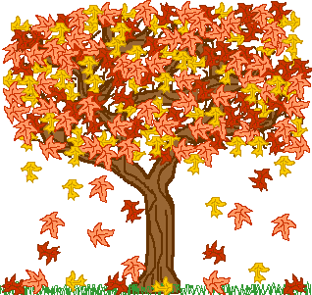 Fall 2022
Calendar
MONDAY | TUESDAY | WEDNESDAY | THURSDAY | FRIDAY
  Sep 26  Classes Begin | 27 | 28 | 29   | 30
Oct. 3 | 4 | 5 | 6 | 7
10 | 11 | 12 | 13 | 14
17 | 18 | 19 | 20 | 21
24 | 25 | 26 Educational  Planning Day | 27 | 28
  31 | Nov. 1 | 2 | 3 | 4
7 | 8 | 9 | 10 | 11 Veterans Day 
14 | 15 | 16 | 17 | 18
21 | 22 | 23 No class | 24  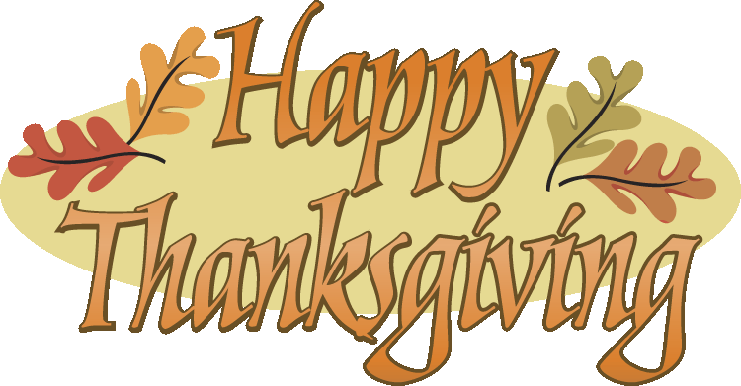 | 25 No class
28 | 29 | 30 | Dec. 1 | Dec. 2
5 | 6 | 7 | 8 | 9
12  Finals | 13  Finals | 14  Finals | 15  Finals | 16
 | Academic Break – Dec. 16—Jan. 3  *According to instructional calendar. |  | Winter Quarter classes begins Jan. 4, 2023

