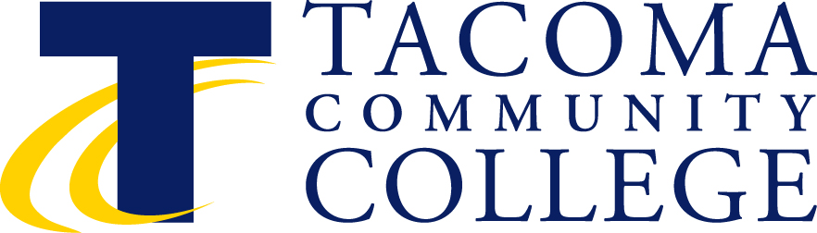

Instructional Council
May 12, 2:30-4:30 p.m.
Building 11, Senate Room
Minutes

2:30-3:25 p.m. Closed Faculty Session

3:30 p.m. Roll Call Val Morgan-Krick
Co-Chair
- Approval of Minutes – April Val Morgan-Krick
- Faculty Forum Items Ken Fox
- Approval of Agenda Tod Treat, Co-Chair

(M Barb Peterson (S) Jackie Gorman

Approved minutes with correction of names Jennifer Sorensen, Jethro De Lisle and Robert Larson.
Minutes approved and agenda with faculty forum items added.

Faculty Forum items
- Questions about campus security – propose time in PDD to address security issues and better understanding of communications and pipeline and a real interest in starting conversation about mental health issues.

Faculty were unaware of communications about building 16 incidents in the women’s restrooms. Will it be possible to have security to come to our June meeting?

Tod will look into adding mental health issues to the Fall PDD topics.

Approve agenda with corrections (M) Bob Schmitt and (S) Bekah Townsend.
Move New Business Item (Update on CRT) before Strategic Plan item.
Informational Items (to update the faculty on institutional issues).

Business Items (to act upon informational items or additional items in the spirit of shared governance)

New Business:

DLO Update for Critical Thinking Kim Rzeszewicz
Core leadership team Julie and Don
Facilitate critical thinking teaching in the classroom
Welcoming all participation
- WRAC
- Standard
- Critical thinking workshop every year
- Keep collecting data English 101 and how to facilitate students taking it early
- Collect examples of critical thinking papers

Old Business:

Endorsement of the 2014-2018 Tacoma Community College Strategic Plan
Rebecca Sliger made a motion for endorsement of the strategic plan in concept Becky Sproat
Seconded
The committee has received only a few comments. Bring your comments to the committee and wordsmiths.
- Ruth Ann Mikels – verbiage preparing students for the workplace, should be broadened to include preparing students who plan to transfer.
- Engaging community – brings community members onto our campus in regards to the arts.
- Embrace discovery – didn’t think that discovery was a right phrase….”discovery learning “ has specific meaning in education.
- Nation-wide there is Complete College America, which sets national goals for community college completion rates. This is being adopted by the state board also.
- Mission statement was done four years ago. Strategic Plan continues to build on the mission.
- Tod explained the intention of the theme Embrace Discovery.
- Discussion of role of “mitigating risks” in educational environment where innovation is encouraged.

- Tod has noted concerns and will go back to the committee with the suggestions.

Table the vote until we see the final version (M) Christie Fierro (S) Jeannette Smith-Perrone
Tod or Val send out changes on Survey Monkey to faculty

Char gore moved to adjourn meeting and second by Jeanette Smith-Perrone meeting was adjourned.

Upcoming Meetings

June 8

¹ Additional Information Available in Sharepoint.

