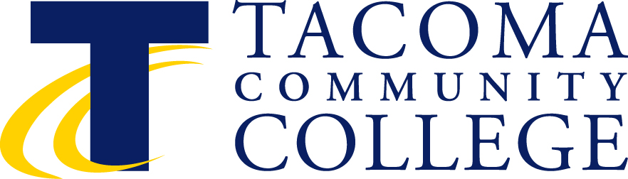

Instructional Council
March 10, 2:30-4:30 p.m.
Building 11, Senate Room
Minutes
(Note: Tod Treat will fill in for Val Morgan-Krick who will miss the meeting.)

2:30-3:25 p.m. Closed Faculty Session

3:30 p.m. Roll Call Val Morgan-Krick
Co-Chair
- Approval of Minutes – February Val Morgan-Krick
(M) Barb Peterson (S)Becky Sproat and Liz Fortenbery
Minutes approved

- Faculty Forum Items Ken Fox

- Approval of Agenda Tod Treat, Co-Chair
Agenda approved by consensus

Informational Items (to update the faculty on institutional issues).

- Response regarding Tenure Line – Board Celebration Continuance
- Celebration should be administration supported and cosponsored
- Food and drink taken care of by administration and union
- Setup needs to be sustainable
- The IC co-chairs will collaborate on planning and organization.

- Update on American Honors.
Pierce College has accepted a contract with American Honors and we are evaluating an invitation to collaborate on particular components of their program.
Ken Fox will co-chair the honors program locally.
Tod Treat thanked the faculty for their work on this honors program. TCC will continue to identify ways to address the instructional and transfer needs of all students, including high performing students.

- Institutional Review Board Mecca Salahuddin
Establish a review board here at TCC to insure that we are protecting our human subjects for institutional review. See portal link below:
https://sites.tacomacc.edu/committees/ic/Shared%20Documents/IC%20Meeting%203%2010%2014/Organizational%20Learning%20and%20Effectiveness%20Division.pdf
Reviewed the process
Human subject research should be voluntary.
Campus -wide process.
- Strategic plan that we would codify our research.
- Ruth Ann suggested it may be time to have FERPA training by HR.
- The college may want to take this opportunity to also train on the IRB process.

- Update on Accreditation. Preparation for the Visit.
- Year seven accreditation
- There are many opportunities to share this information in the report.
- The Accreditation schedule is on the portal.
Pointers – answer the question and answer it honestly if you don’t know say that you don’t know. One recommendation we may get from the visit is a financial audit.

The TCC Accreditation bracket is out there for you to enter to win gift certificates.

- Update on Strategic Planning. Draft for review at April IC.
We will have a draft of the strategic plan in April. The Strategic Plan will be important for the next four years.

Business Items (to act upon informational items or additional items in the spirit of shared governance)

Old Business:
Endorsement of the DLO Report, Communications and ITT. Kim Rzeszewicz,

More than 50% of our students perform better if they complete English 101 early.

The council thanked the accreditation team for their accreditation tips.
Kim is asking for endorsement of this DLO Report.
(M)Barb Peterson moved to endorse this DLO Report and Becky Sproat seconded
The DLO Report was approved by IC members.
New Business:
- Endorsement of a Tenure Process Review Task Force
Val Morgan-Krick (Math) and Tod Treat (EVP), co-chairs
Barb Peterson, Human Services
Camille Lowman, Respiratory Therapy
Kathy Brown, Counseling
Phil Hunter, Chemistry
Pam Costa, Psychology
Mary Dewine, Transitional Studies (current probationer)

Modification of list added a dean
Suggestion also made to add a union representative on this committee
Assurance that no member will also be on either the faculty or administration negotiations teams to ensure there is no conflict of interest.
Change the taskforce name to Tenure Handbook Review Taskforce.

Reviewing the tenure handbook
Are you okay with the handbook the way it is or do we need to update and make it relevant to today’s environment.

Approve this committee with the name being changed to Tenure Handbook Review with the addition of a dean and one person wearing the union hat added to the committee.

(M) Barb Peterson (S) Becky Sproat --- Motion was approved.

- Discussion of Systematic Approach to Shared Governance/Committee Formation and connection to Instructional Council.
  - Authority
  - Representation
  - Term of Service
  - Connection to Instructional Council
IC is the connecting body to the other faculty bodies
Ken Fox – We would like to know more about the awards process. . There was some question about how the professional development awards will be processed: what group/committee would make the decisions about sabbaticals, teaching awards, etc. The concern is that the professional development committee might not be the best group to do this since they are self-selected. Tod will have Mecca come to the April meeting if available for this discussion.

Requested clarity of the email Tod sent out. Tell us your vision --- Discussion of chart.
https://sites.tacomacc.edu/committees/ic/Shared%20Documents/IC%20Meeting%203%2010%2014/Governance%20and%20Management.pdf

Moved to adjourn meeting at 4:30 pm. Meeting was adjourned.

Upcoming Meetings

April 14 May 12 June 8
March 18-20 NWCCU Accreditation Site Visit

¹ Additional Information is Available in SharePoint.

