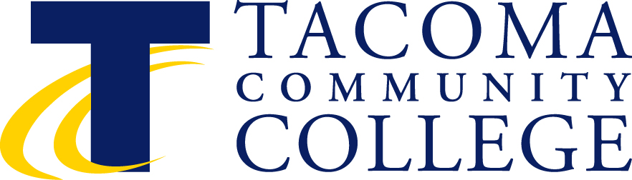

Instructional Council
February 10, 2014, 2:30-4:30 p.m.
Building 11, Senate Room
Minutes

2:30-3:25 p.m. Closed Faculty Session

3:30 p.m. Roll Call Val Morgan-Krick
Co-Chair
- Approval of Minutes – January Val Morgan-Krick
(M) Barb Peterson (S) Kathy Brown
Minutes approved
- Faculty Forum Items Ken Fox
      - Tenure Celebration
Funding, location and planning group?
Brandi Eastman and Jackie Gorman have taken lead in the past. Val and Tod will meet to discuss how to proceed to ensure the celebration falls under some committee’s/position’s responsibilities.
- Approval of Agenda Tod Treat, Co-Chair
Faculty forum item - tenure celebration approved to add to agenda.

Agenda was approved

Informational Items (to update the faculty on institutional issues).

- Informational Item Policy regarding Memorial Degrees Mary Chikwinya
Policy developed to move from 30 to 45 TCC credits in order to receive a memorial degree.

- Update on American Honors
Exec staff and our AG are reviewing a draft contract.

We are continuing to have conversations regarding the contract and as soon as we get this ironed out we will give you an update.

- Update on Accreditation
Tod thanked the writing team.
If you read the accreditation document you will find that you have accomplished a lot.

We are waiting to receive the list of who the accreditation committee will want to interview.

Kim Rzeszewicz is sending out emails on items to familiarize you on the topics in the accreditation report.

Tod expressed appreciation to all that worked on the accreditation teams.

- Update on Strategic Planning
We have five teams working on current standards and core themes and objectives that are associated with those themes and are checking that they are relevant, or have been filled and need to be removed.
Four teams are active and consist of internal stakeholders.
One team headed by Charlie is focused on innovations
Environmental scan team – goal is to have this scan completed in March

- Update on Annual Planning (Equipment, Personnel, Operational Plan)
Tod has been in contact with department chairs and in conversations with deans.
“Gains, gaps and goals” is theme driving annual planning.
Look at the data that you have already received to make your plans.

- Survey of Community College Survey of Student Engagement (CCSSE) – sampling timeline. Administration will communicate with CCSSE regarding timeline for sample: the goal would be to have the info about which classes will be part of the sample before the quarter actually begins.
We heard from 2 or 3 people that they did not want to do it again. We will ask CCSSE to give information on classes that will be surveyed, but the timeline is driven by CCSSE. The survey work we do as an institution takes instructional time but it is not unimportant work because it drives back into the college. We use the results to do improvement work.

Old Business:

New Business:

- First Reading for Endorsement of the DLO Report,
Communications and ITT. Kim Rzeszewicz

DLO Link

Kim is asking for IC to endorse this report from last year.
See handout
Core leadership team was formed WRRAC
Kim will have on the next IC meeting agenda to endorse.

Living and working cooperatively survey we had a good response over 300 have responded.
English 101 communications DLO and Critical Thinking DLO looked at it as if the student had taken HD101.

Dave moved to adjourn Barb Peterson seconded.

Upcoming Meetings

March 10 April 14 May 12 June 8

March 18-20, 2014 - NWCCU Accreditation Site Visit

¹ Additional Information Available in SharePoint.

