**Accepting\Rejecting\Viewing a Contract in the Faculty Center**

**Navigation:**

**Main Menu> Self Service > Faculty Center> Contract Info**

* **Or -**

**Faculty Center** located on the left side pane under the college logo.

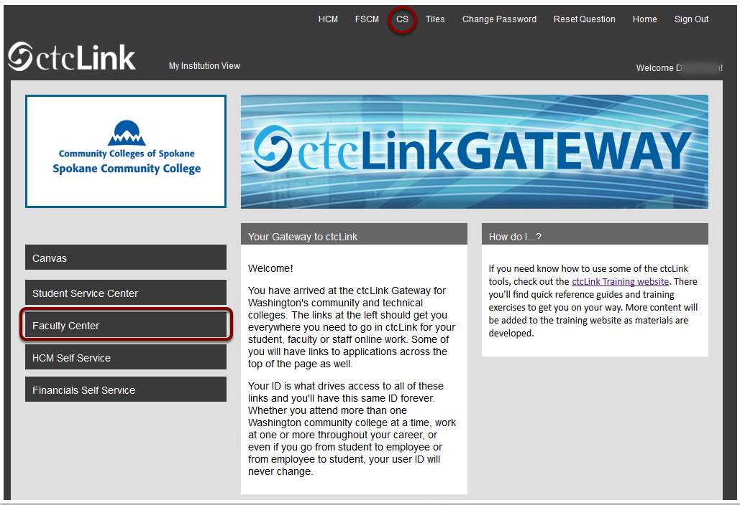



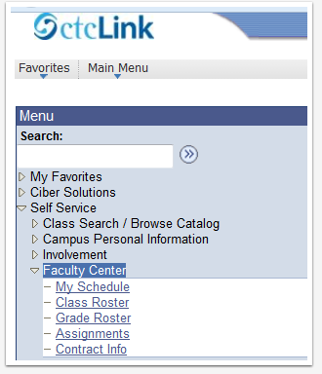

**On the Contract Info page in the Faculty Center all contracts (appointment letters) are displayed, listed by Term.**

1. Find the contract to be signed, shown below as missing a check in the Contract Signed check box.
2. Click on the View Contract link to the right of the check box.

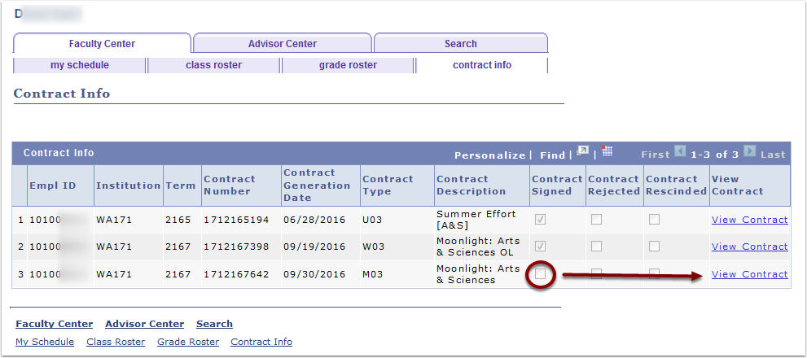

1. Scroll to the bottom of the electronic contract (appointment letter), under the contract generation date the Accept and Reject buttons are displayed.
2. To the right of the contract generation date, in the Initials field, enter your initials, representing your electronic signature on the contract, which is stored in the contract along with the User ID and date/time stamp of the person signing the contract.

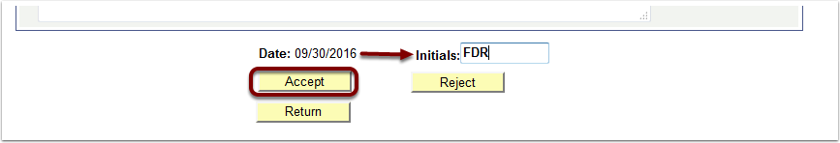

1. If the Accept button is clicked, a pop up message will appear, confirming the intention to accept the contract.  Click Yes to confirm.

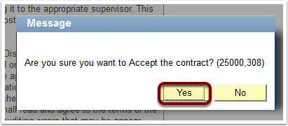

1. After accepting the contract, the Print button will appear, enabling the printing of the contract on a network printer.
2. To exit the contract and return to the Contract Info page on the Faculty Center.

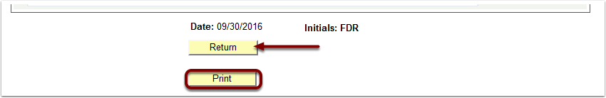

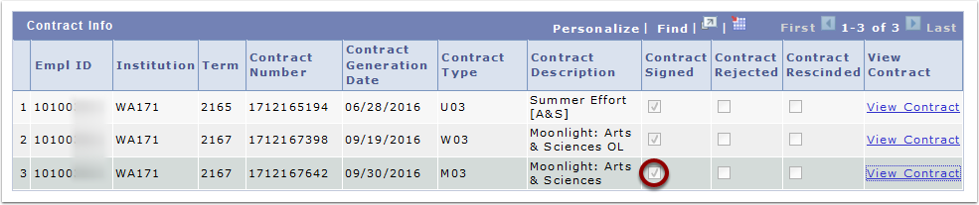

1. If the Reject button is clicked, a pop up message will appear, confirming the intention to reject the contract.  Click Yes to confirm.
2. The system requires Initials to be entered before clicking the Reject button, if not entered, an error message will appear enforcing the requirement.

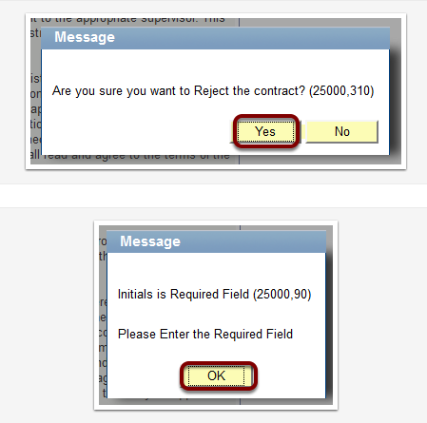

1. When rejecting a contract, the system allows, but does not require entry of a reason for the contract rejection.

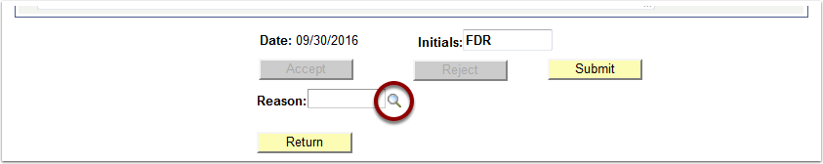

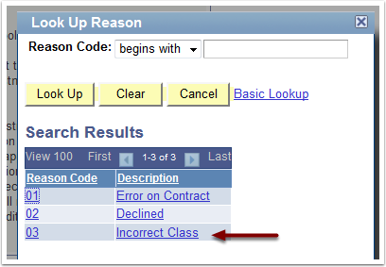

1. Once a contract rejection reason is selected, it will populate both code and description on the page.
2. Click the Return button to exit the page and return to the Contract Info page.

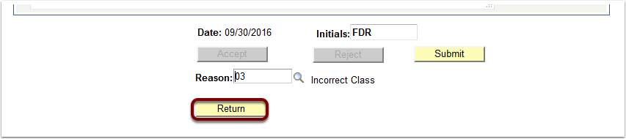

1. Once returned to the Contract Info page, a check will appear in the Contract Rejected check box.

