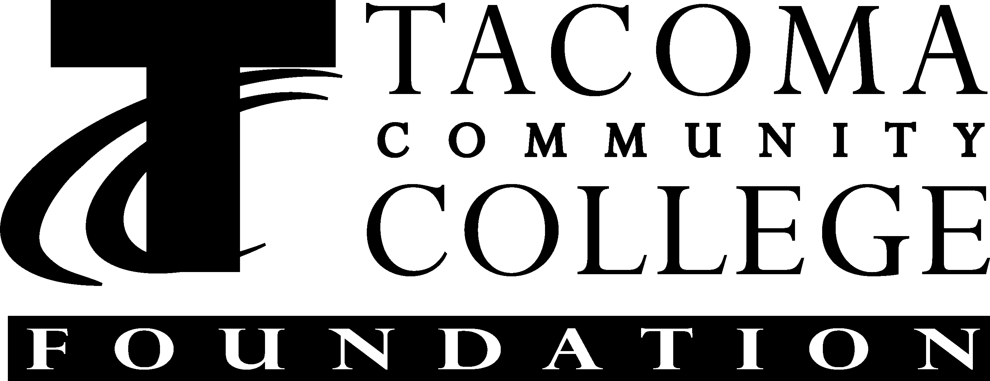

CLASSIFIED STAFF INDIVIDUAL PROFESSIONAL DEVELOPMENT FUNDS
Individual professional development activities improve the job skills of TCC employees, increase the ability of employees to support student success and contribute to the accomplishment of the college’s mission, and enhance opportunities for employees to advance in their careers at TCC.
There are two funds available for Tacoma Community College classified staff to utilize to pay for individual professional development activities. The dollars in each fund are awarded annually on a first-come, first-served basis until the fund is exhausted. Depending on eligibility, classified employees may request up to $200 from the Classified Staff Council funds and $200 from the Tacoma Community College Foundation Classified Staff funds. Both funds may be utilized to pay for . . .
- Tuition for college courses
- Textbooks for college classes
- Registration fees for professional workshops and seminars.
In addition, Foundation dollars may be utilized to pay for . . .
- Membership in professional organizations.
Although each of the two funds has slightly different guidelines, there is now only one form to request funds from either or both funds.
Classified Staff Council funds – are state operating dollars allocated each year by the college Executive Staff to the CSC which in turn budgets dollars for individual professional development activities, Breakaway and other staff development activities. These funds may only be utilized by permanent classified employees. Permanent classified employees must utilize $200 of these funds before requesting Foundation Classified Staff funds (except in the case of (a.) below).
Tacoma Community College Foundation Classified Staff Funds – were created from the Endowment Challenge Campaigns of 1992 and 1994. A portion of the annual earnings from the endowment is budgeted each year for individual professional development activities. These dollars may be utilized by . . .
a. full-time classified staff who have spent $200 from the Classified Staff Professional Development Committee, or who are requesting membership in a professional organization, and by
b. part-time classified and part-time hourly employees who have worked a minimum of 70 hours with no more than a three-month break in service.
The learning activity for which any funds are requested must meet at least one of the following criteria . . .
  - Training to improve performance and productivity in current position.
  - Training to learn new skills and knowledge to meet new job requirements brought about by technological or program changes.
  - Training to enable employees to qualify for promotional opportunities.
  - Retraining for other fields of endeavor for employees whose skills may have changed due to physical disability.
  - Training to enhance morale and motivation.
  - Individual memberships in professional organizations related to current position (endowment funds only).
Requests for funds must be submitted before the activity begins; requests for reimbursement must be submitted before the end of the current fiscal year. If an employee is planning to depart the college, funding requests for courses after the employee’s departure cannot be fulfilled. Additionally, funding requests cannot be fulfilled for prior courses/expenses once an employee departs. It is recommended that all requests be submitted promptly to ensure that funds are available and to allow sufficient time for processing (2-3 weeks).
REQUEST PROCEDURES:
- Complete the Classified Staff Individual Professional Development Funding Request Form.
- Attach all necessary documents (workshop agenda, completed registration form, completed voucher distribution form, personal check, original itemized receipt if requesting reimbursement, etc.). It is highly recommended that you make a copy of the Funding Request Form and supporting documents for your records.
- Send the completed Funding Request Form and all related documents to your supervisor for signature (and budget number if some of the costs are being shared).
- Then send the packet to . . .Cora Warren, Building 18
When your request has been approved for either or both funds, Cora will forward the forms to the appropriate signatories, and then it will be sent to the Business Office and/or Foundation for processing. If you have any questions, please call Cora at x5074.
last updated : 06/24/09

Classified Staff – Funding Request Form

Section 1 – Employee

Employee’s Name: Date:
Position: Department:
Employment Status: Full-Time Permanent Classified Part-Time Classified
Part-Time Hourly
Name of Event: Date of Event:
Purpose of Event:
How is this event job-related?:
Funds are being requested for….
Workshop/Seminar Registration $
College Course Registration $
College Course Textbooks $
Professional Organization Membership $
Other: $
TOTAL $
Section 2 – Supervisor
Do you support this training? Yes No
If this employee is a P/T classified or P/T Hourly employee, do you verify this employee has worked a minimum of 70 hours with no more than a three-month break in service? Yes No
Section 3 – Signatures

Employee Signature Date Supervisor’s Signature Date
Section 4 – To Be Completed by the C.S.C.

❑ Approved for:CSPDC Funds (081-181C)Endowment Funds (265-5018)
Registration for College Course$$
Registration for Workshop/Seminar$$
Textbooks for College Course$$
Membership in Professional Organization$$
Other:$$
TOTAL……………………………………………..$$
❑ Not Approved (see attached explanation)

C.S.C - Treasurer SignatureC.S.C – Chair Signature

Associate VP Human Resources Signature

