**Faculty Center - Entering Grades**

**Purpose**: Use this document as a reference for entering grades in ctcLink.

**Audience**: Faculty

**Grade Roster**

**Navigation: Gateway → Faculty Center → My Schedule**

**NOTE: Save entries often as data will be cleared/lost if page times out.**



1. On the **My Schedule** page, verify you are viewing the correct term and institution, if necessary, click ***Change Term*** button to change between terms or institutions.
2. To view the grade roster for an individual course click the **Grade Roster** icon next to the appropriate class.

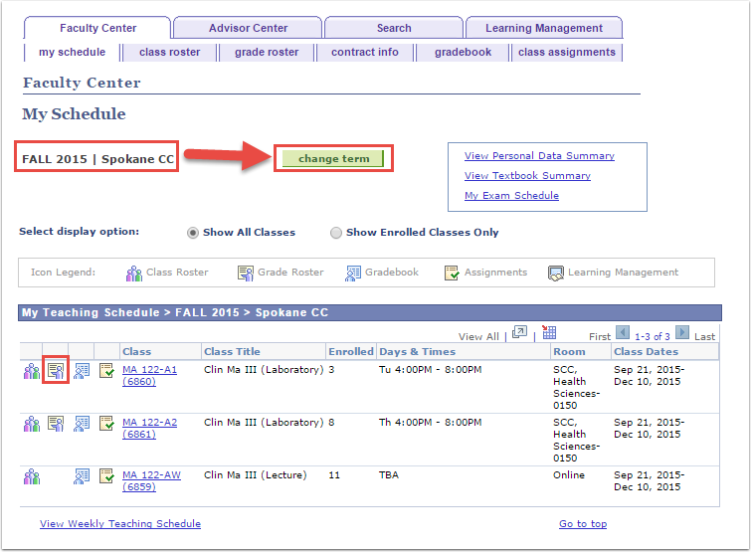

1. This will open the **Grade Roster** tab for the course selected.

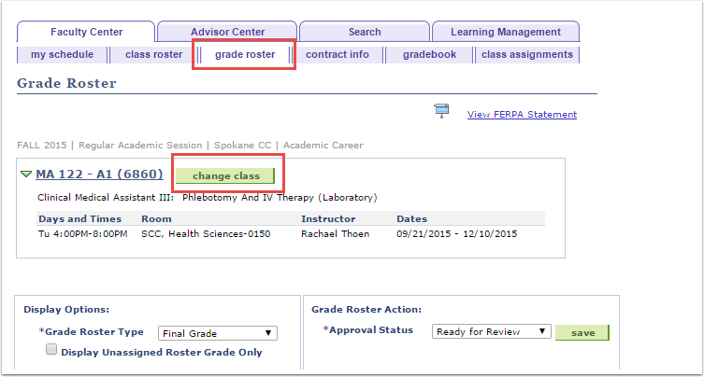

1. To Change between classes, click the **Change Class** button, this will return you to the **My Schedule** tab and you will need to select the **Grade Roster** icon (step 2 above) for the class you wish to view.
2. To Enter Grades:
   1. Select the appropriate grade from the drop-down box in the **Roster Grade**

column next to each student’s name.

* 1. After entering all student grades, the **Save** button.

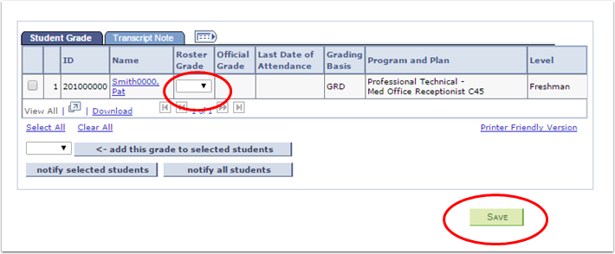

1. After all grades are entered and saved, review them for accuracy, and change their status to **Approved** in the **Approval Status** drop-down box to submit as final grades.

**Note:** Changing **Approval Status** before grades are saved will cause all grades to be

lost. You must save grades before approving them.



1. Choose the appropriate **Approval Status** from the drop-down menu and then click the **Save** button.

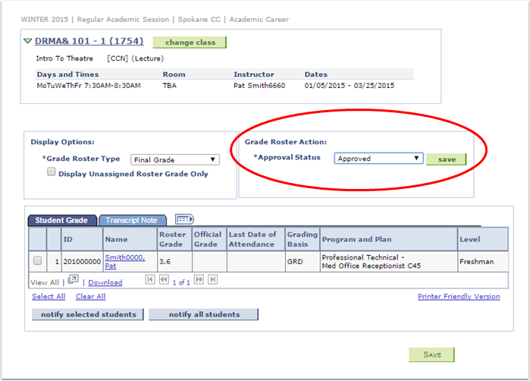

Once the grades are saved in Approved status, you will need to contact the Records

office to make changes.

