Background Document to “Standardized Cleaning Products” Policy

Overview on Cleaning Chemicals and Best Practice

For the past two years, the Custodial Department has been using green cleaning chemicals and has consciously aimed at promoting sustainable practices. This has

taken the form of purchasing new equipment, which renders corrosive wax stripper obsolete; removing bleach from the Early Leaning Center; adopting low-water, encapsulation carpet cleaning; and ordering chlorine-free paper towels, which have 100% recovered material. The Custodial Department’s focus has been on using cleaning chemicals that promote a healthy indoor air quality for all building-users, and to be mindful of the impact those chemicals have on the environment. Currently, the Custodial Department is supplying green cleaning chemicals to various departments within Tacoma Community College, on-demand.

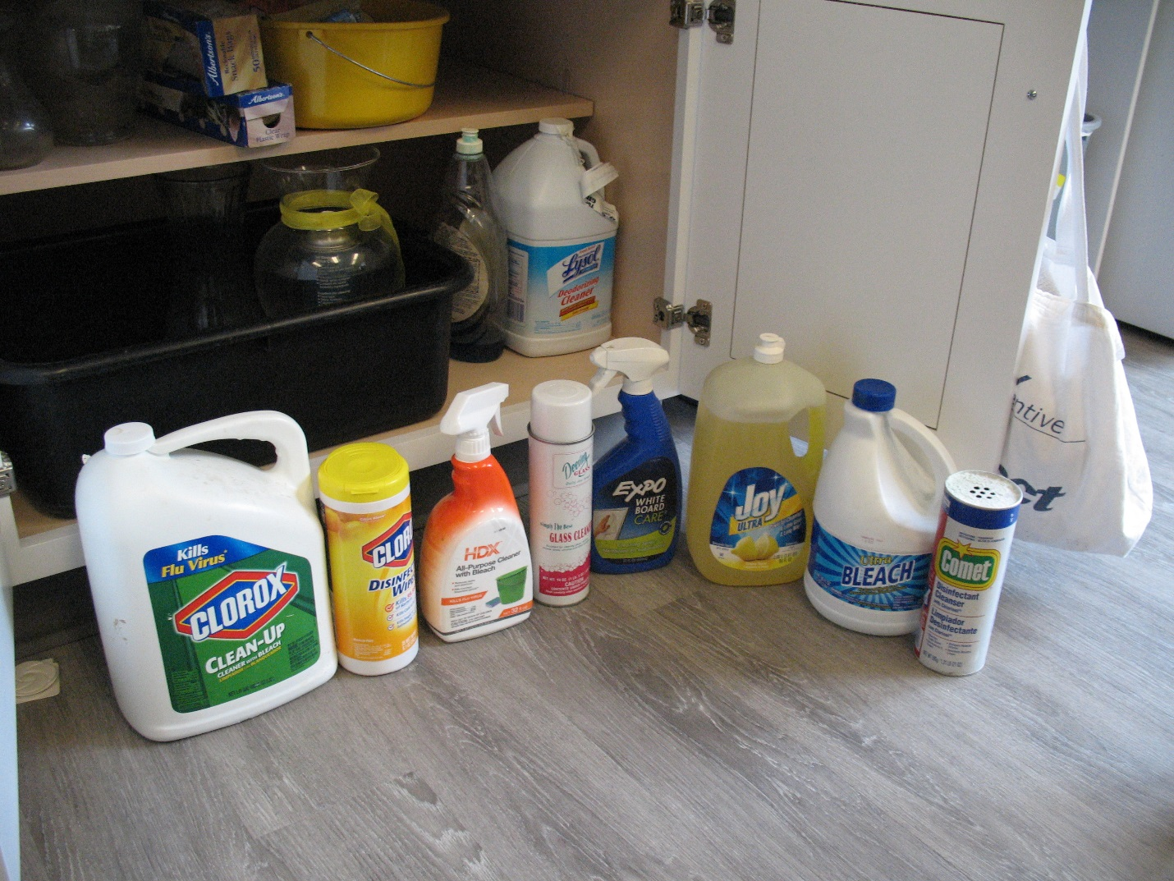

Nevertheless, it defeats the purpose of having a green cleaning standard, when College staff bring in cleaning chemicals, without taking into account indoor air quality, or the impact on the environment. As the image above shows, unhealthy cleaning chemicals are brought onto campus by staff. Therefore, best practice would entail prohibiting staff from bringing such chemicals onto campus, and aligning the College with the Custodial Department’s de facto green cleaning policy. The following tables illustrates the point:

|  |  |  |  |  |
| --- | --- | --- | --- | --- |
| **Brand Name** | **Active Ingredient** | **Problem** | **Examples of Informed Substitution** | **Active Ingredient** |
| Clorox Disinfectant Wipes | d-Limonene | Bioaccumulate toxicant in the environment.  Sensitizing effect on people1 | Purell Alcohol Formula wipes | Isopropyl alcohol |
| Clorox Bleach-free Wipes | Quaternary Ammonium Compound (quat) | One of the quats is benzyl ammonium chloride, which may cause asthma2 | Purell Alcohol Formula wipes | Isopropyl alcohol |
| Bleach | Sodium Hypochlorite | May cause/exacerbate asthma3,4 | Diversey Oxivir disinfectant | Hydrogen peroxide |
| Windex | Ammonium Hydroxide | May cause/exacerbate asthma4 | Diversey Glance NA (non-ammoniated) | Alcohol ethoxylates,  Sodium lauryl sulfate |
| Simple Green | Methylchloroisothiazolinone   |  | | --- | |  | | Irritates eyes and skin5  Toxic to land and aquatic ecosystems6 | Diversey Stride neutral cleaner | Alcohol ethoxylates |
| Antibacterial soap (Dial, etc.) | Triclosan | Persistant Bioaccumulative Toxicant7 | Gojo Fragrance-free foaming soap | Sodium lauryl sulfate |

Note: Stride and Glance NA, are Green Seal approved cleaning chemicals used by the Custodial Department. Oxivir, Purell and Gojo are also used by the Custodial Department.

Green Seal

The Green Seal organization is a non-profit, which sets standards for cleaning products. By adhering to products recommended by Green Seal, the College can be assured that a good faith effort has been made to source cleaning products, which meet exacting standards of efficacy and safety. Tacoma Community College Custodial Department, adheres to the Green Seal Organization’s GS-37 standard.

To be recommended, a chemical manufacturer has to ensure that their product meets Green Seal’s criteria, found under the following headlines: Efficacy, toxicity, skin and eye damage, carcinogens, ingredients that cause asthma, skin sensitization, skin absorption, prohibited ingredients (heavy metals and phthalates), ozone depleting compounds, volatile organic compounds (not to exceed 0.5%), inhalation toxicity, toxicity to aquatic life, bio-accumulating compounds, combustibility, fragrances, colorants, animal testing, and packaging.

Disinfectants and Wipes

Disinfectants are not recommended as general-purpose cleaners. Disinfectants are important chemicals within the context of daycares, and in reducing the spread of germs in flu season; however, for typical office or classroom environments, a pH neutral, general-purpose cleaner will suffice.

The Custodial Department uses disinfectant on touch-points throughout campus during flu season, and can provide disinfectant to departments at that time. The flu season generally runs from October through April.

Disinfectant wipes are frequently used as general-purpose cleaners, especially where there is no ready water access. However, the Custodial Department can fill spray-bottles with neutral cleaner, and therefore provide an informed substitution for disinfectant.

Moreover, for wipes to actually disinfect, a non-porous surface must be free of soil for the disinfectant to be effective. A two-step process is required: remove soil with a general purpose-cleaner, then use the disinfectant wipe. As typically used, disinfectant wipes do not kill anything; efficacy as a disinfectant requires ten minutes of continuous, visible wetness to kill E. coli, Salmonella, Listeria or Staph bacteria, for example, and one minute of continuous, visible wetness to kill the flu virus.

Cost Analysis of General-Purpose Cleaners

Simple Green, 32 fl.oz. ready to use: $6.49

Stride Neutral Cleaner, 32 fl.oz. (mixed from concentrate): $0.04. Cost based on a $54.30, 5-liter concentrate jug yielding 339.32 gallons of solution, at a ratio of 1:256, chemical to water.

General References

Healthy Cleaning and Asthma-Safer Schools: A How-To Guide, California Department of Public Health, 2014

Tools for Informed Substitution, WorksafeBC and the British Columbia Government and Service Employees Union

[www.chemhat.org](http://www.chemhat.org). Chemical Hazards and Alternatives Toolbox,

Quaternary Ammonium Compounds in Cleaning Products, New York University.

What’s the Problem with Bleach? Green Cleaning, Sanitization, and Disinfection: A Toolkit for Early Care and Education. UC San Francisco.

Notes:

1. *Regulation on the Classification, Labelling and Packaging of Substances and Mixtures (CLP)* Annex 6 Table 3-1 - GHS Hazard code criteria. European Union, European Commission. 2007.

2. Bernstein JA, et al. 1994. *A combined respiratory and cutaneous hypersensitivity syndrome induced by work exposure to quaternary amines*. Journal of Allergy and Clinical Immunolology, 94(2 Pt 1): p. 257-9.

Burge PS and Richardson MN 1994. *Occupational asthma due to indirect exposure to lauryl dimethyl benzyl ammonium chloride used in a floor cleaner*. Thorax, 49(8): p. 842-3

Purohit A et al. 2000. *Quaternary ammonium compounds and occupational asthma*. International Archives of Occupational and Environmental Health. 73(6): p. 423-427

Rosenman K. (2006). Cleaning products-related asthma, Obstructive Airway Disease. Clinical Pulmonary performance. 13(4):221–228.

3. Association of Occupational and Environmental Clinics (AOEC), *AOEC Exposure Codes - Asthmagen List*

4. *Healthy Cleaning and Asthma-Safer Schools: A How-To Guide*. California Department of Publich Health. 2014. Appendix A, p.43.

5. New Zealand Environmental Protection Authority (NZ EPA), *New Zealand HSNO Chemical Classifications*. 6.1B, oral, dermal, inhalation.

6. *Korea GHS Classification and Labelling for Toxic Chemicals Republic of Korea* - National Institute of Environmental Research (NIER)

7. Oregon Department of Environmental Quality (ORDEQ), *Priority Persistent Pollutant (P3) List*. Priority Persistent Pollutant - Tier 1