How to Apply to the TCC NAC program:
- Sign in to the TCC student portal.
- Click on the square waffle icon in the upper right corner to expand options.
- Select “All Applications”
- Select Allied Health/Nursing Link
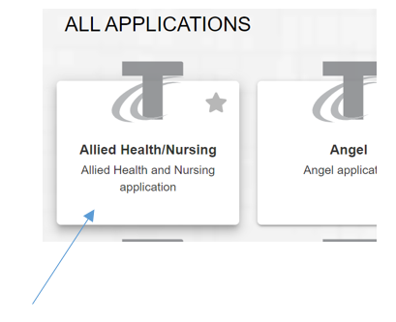
- Select NAC Gig Harbor Program
- Fill out the application. Requested documents must be uploaded or your application will not be successfully submitted.
- Click Submit.
**Please check your TCC student email for a confirmation e-mail notifying you that your application was submitted successfully.
Each cohort is filled on a first come first serve basis, with the applicants that have submitted a complete application. Upon receipt of an application, the program reviews the application to ensure all items are complete. If incomplete application received, the applicant will be notified of what is needed to complete the application. If complete, the applicant will be given permission to register. Note that only complete applications will be placed into the queue for permission to register.
All communication from the program occurs using only the TCC student e-mail. Be sure to check your TCC e-mail frequently after you have applied.

