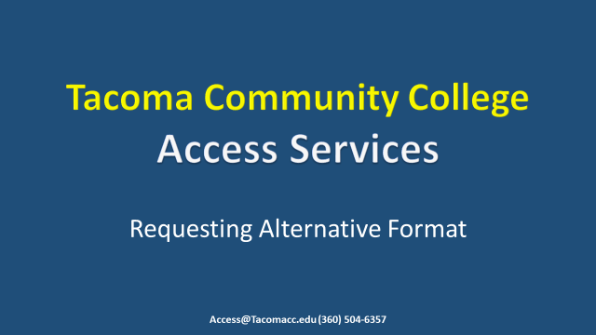

Welcome to Access Services at Tacoma Community College. Thank you for joining us for this tutorial. Here, steps will be provided to show you how to request your Alternative Format by quarter.

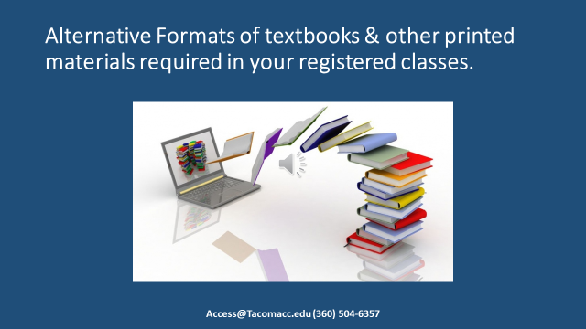
This Accommodation is specifically for Alternative formats of textbooks and other printed materials required in your registered classes. You are required to submit a request for materials each quarter. This service may not apply if there are no assigned textbooks for a given course or if the textbook is already provided electronically.
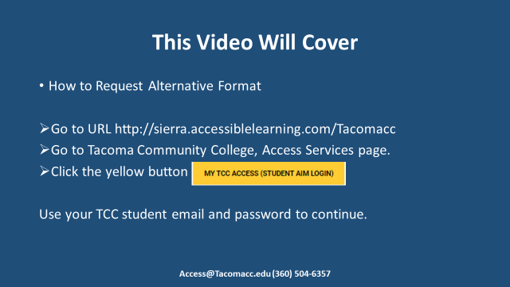

This video will cover; How to Request your Alternative Format. First steps you will take, is to log into AIM one or two ways. Navigate to URL https://sierra.accessiblelearning.com/Tacomacc OR Go to Tacoma Community College, Access Services page and click on the yellow button MY TCC ACCESS STUDENT AIM LOGIN. Either way you log in aim you will be required to use your TCC student email and password to continue.

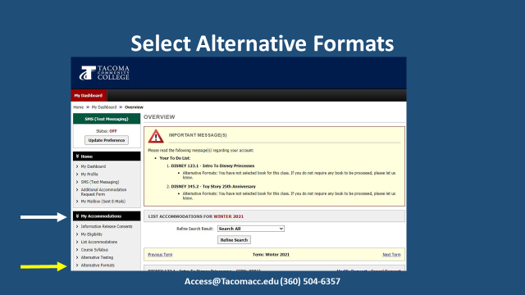

You are now on your My Dashboard page. Under the My Accommodations tab, click Alternative Formats. On the next screen you can begin requesting your textbooks.
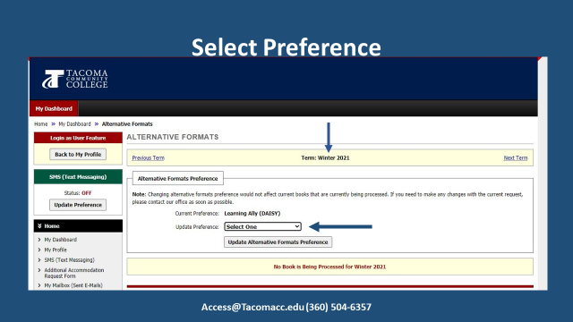

From this screen you can begin requesting your textbooks. Make sure you are on the correct semester you are requesting your books for. You can find what semester you are in at the top of your screen. If you have not done so previously, select your format preference in the drop down under Alternative Formats Preference near the top of the page. Click the Update Alternative Formats Preference button. You will then see a green check mark at the top of the page indicating that your update is successful.
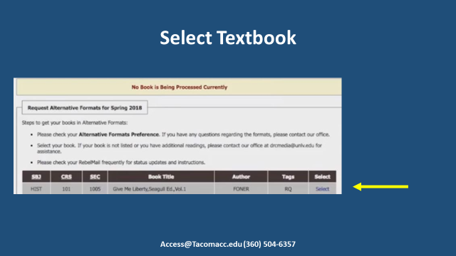

This is where TCC Bookstore textbooks are populated. Scroll down to the “Request Alternative Formats” section. Your textbooks will be listed in this section of the page. Simply click on select, to the right of the title of the desired textbook. Do this for every textbook that you are requesting. If this selection is not here please scroll down further to the “Additional Book or Reading Materials” You will again see a green check mark at the top of the page indicating your request was successful.
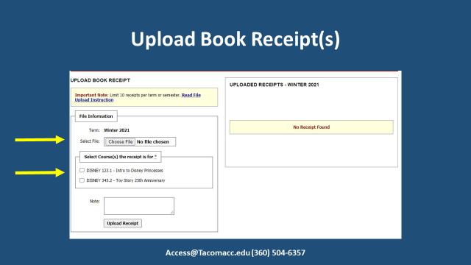

If a Publisher is requesting proof of purchase Access Services will notify you. You will then need to upload your receipt by completing the “Upload Book Receipt” portion. Simply select the file to upload and then select the course. Add any additional information under notes. Then select Upload Receipt.

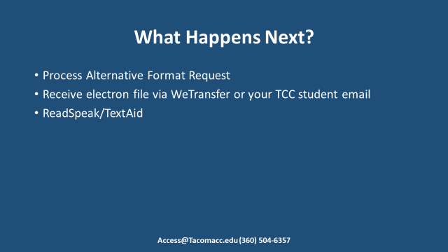

What happens next? Your request will be reviewed and processed. If any additional information is required Access Services will contact you. Otherwise, your electronic textbooks will be emailed to your TCC student email address via WeTransfer for you to download. Additional videos will follow with how to use ReadSpeak/TextAid. This software is integrated in your Canvas page already. You will be able to upload the electronic textbook into ReadSpeak/TextAid so that it can be read out loud or magnified.

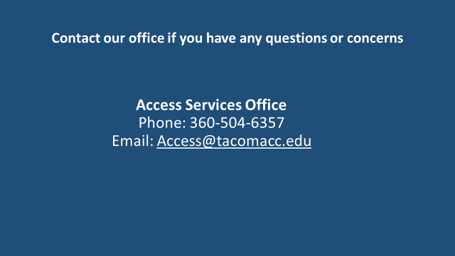

If you have any questions or concerns during the process, please contact Access@tacomacc.edu or (360) 504-6357. Thank you for joining the tutorial on how to request your Alternative Format by quarter.

