ASSISTIVE TECHNOLOGY AVAILABLE TO CLASS STUDENTS

The following Assistive Technology software programs are available for loan for students who work with the Access Services and qualify for use. Some of these items may be checked out for personal and classroom use. For more information, please contact Assistive Technology Coordinator at 360-504-6357 or email: access@tacomacc.edu.

READING/LITERACY SUPPORT:

Kurzweil

Snap & Read
ReadSpeakers

NOTE-TAKING SUPPORT:

Otter Ai
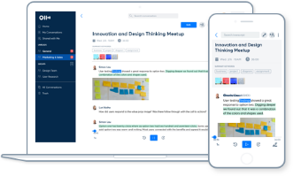
Otter turns your voice conversations into smart notes that you can easily search and share. You can use it to take notes at your meetings and interviews, capture your thoughts and ideas while you’re driving in the car, and transcribe your existing recordings and podcasts. You can even snap photos (e.g. of a whiteboard, or a speaker or presentation slide at an event) during a recording and they will be inserted in line with your transcripts. The possibilities are endless.

Livescribe smartpen
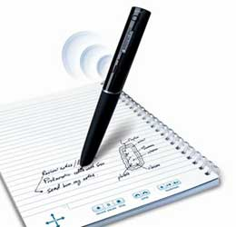
The Livescribe smartpen captures everything that you write and everything that is spoken. Inside the pen is a camera that takes a picture of your notes as you write them. ... Later on you can go back and listen to any part of the audio recording by tapping anywhere on your written notes. Tech-tips/livescribe-smartpen/

DICTATION:

Digital Voice Recorders
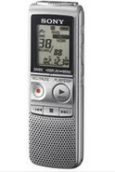
Digital Voice Recorders record your lectures on a portable device. You can listen to your lectures on the device or upload them to your computer using the USB cable (included). The folder system allows you to organize recordings by class.

Google Voice Typing
Google Voice Typing is a speech to text program. By uses simple voice commands to assist with typing in a Google Doc. It is built into Google platform. Compatibility with Windows, Mac, IOS, Android Support.google.com

SCREEN READERS/MAGNIFICATION SOFTWARE:

Natural Reader

NVDA

BUILT-IN ACCESSIBILITY:

Windows
Personalize your Windows Computer with any of the build-in Accessibility Features to support ease with seeing, hearing, and mobility interactions with computer. Features Available Are: Screen Reader/Text-to-Speech (Narrator), Magnification (Magnifier), Keys Commands (Mouse Keys), Speech-to-Text and Voice Control (Speech Recognition), Visual Notification to replace sounds, Keyboard on Screen, Toggle Keys, Adjustable Mouse Settings, High Contrast Schemes, and Ability to Personalize the Appearance of the Computer including text. For more information: Microsoft.com

Mac
Personalize your Mac Computer with any of the build-in Accessibility Features to support ease with seeing, hearing, and physical/mobility, literacy interactions with computer. Features include: Text-to-Speech (VoiceOver), Zoom, High Contrast, Sticky Keys, Speech-to-Text and Voice Control (Speech Recognition), Word Completion (Word Prediction), and more! More Information: Apple.com/accessibility

Google Suite

Sound amplification:

Pocket Talker
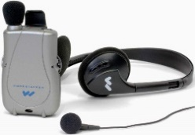
Use of Pocket Talker to amplify lecture in the classroom. Use with or without hearing aids. Simply plug in your earpiece, position the microphone near the preferred sound, adjust volume to your comfort – and start listening.

