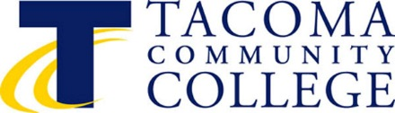

TACOMA COMMUNITY COLLEGE

BOARD OF TRUSTEES

6501 South 19th Street TENURE MEETING
Tacoma, WA 98466 Wednesday, March 13, 2018
11:45 – 4:15 p.m.
Board Room, Building 12

SPECIAL MEETING OF THE BOARD OF TRUSTEES
March 13, 2019

AGENDA

I. CALL TO ORDER James Curtis

II. ADJOURN INTO EXECUTIVE SESSION REGARDING TENURE James Curtis

III. RECONVENE INTO OPEN PUBLIC MEETING James Curtis

IV. BOARD ACTION AS A RESULT OF EXECUTIVE SESSION James Curtis

A. First Year Faculty Advancing to Second Year Ivan Harrell
B. Second Year Faculty Advancing to Third Year Ivan Harrell
C. Third Year Faculty Tenure Consideration Ivan Harrell
D. Fourth Year Faculty Tenure Consideration Ivan Harrell

VI. ADJOURNMENT James Curtis

Interpreters for people with hearing impairments and Braille or taped information for people with impairments can be provided. Please contact Angelique Odom, Office of the President at 6501 South 19th St., Tacoma WA 98466; Tel: 253/566-5136; Telephone Device for the Deaf TDD 253/566-5169; or e-mail: aodom@tacomacc.edu.

